# A Case study on Regenerative Braking and it’s effects on the automobile industry

# *Shrawani Shinde, Shaunak Deshpande, Gaurav Shejwal, Shivang Singh*

# Department of Instrumentation and Control Engineering

# Vishwakarma Institute of Technology

# **Abstract**

As the automobile sector progresses, there has been a huge emphasis on switching from traditional internal combustion engine vehicles to electric vehicles. A feature that is feasible to implement in this new category of vehicles is Regenerative braking. Regenerative braking is an energy recovery mechanism that slows down a moving vehicle by converting its kinetic energy into a form that can be either used immediately or stored until needed. This increases efficiency and also extends the life of the braking system, as the mechanical parts will not wear out as quickly.

# **The Traditional Braking system**

A brake is a mechanical device that inhibits motion by absorbing energy from a moving system. It is used for slowing or stopping a moving vehicle, or to prevent its motion, most often accomplished by means of friction. Brakes commonly use friction between two surfaces pressed together to convert the kinetic energy of the moving object into heat. Generally, automobiles only use frictional brakes in them, but in other use cases, there also exist brakes who convert kinetic energy to potential energy in the form of pressurized air (such a system is called Compressed air energy storage). Friction brakes are often rotating devices with a stationary pad and a rotating wear surface. Common configurations include; a rotating drum with shoes that expand to rub the inside of a drum, commonly called a "drum brake", and pads that pinch a rotating disc, commonly called a "disc brake".

Drum brakes generally can be found on older car and truck models. However, because of their low production cost, drum brake setups are also installed on the rear of some low-cost newer vehicles. Compared to modern disc brakes, drum brakes wear out faster due to their tendency to overheat.

The disc brake is a device for slowing or stopping the rotation of a road wheel. A brake disc ,usually made of cast iron, is connected to the wheel or the axle. To stop the wheel, friction material in the form of brake pads ,mounted in a brake caliper is forced mechanically or hydraulically against both sides of the disc. Friction causes the disc and attached wheel to slow or stop.

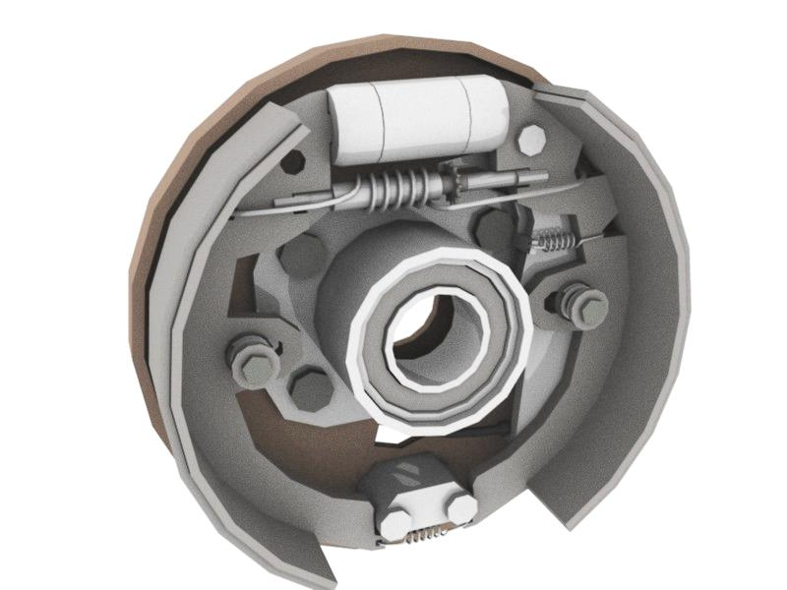

Figure 1 A drum brake[3]

* 1. **Regenerative Braking System**

A regenerative braking system is an energy recovery mechanism that slows down a moving vehicle by converting its kinetic energy into a form that can be either used immediately or stored until needed.

In this mechanism, the motor uses the vehicle's momentum to recover energy that would otherwise be lost to the brake discs as heat. This contrasts with conventional braking systems, where the excess kinetic energy is converted to unwanted and wasted heat due to friction in the brakes.

It increases efficiency, and extends the life of the braking system, as the mechanical parts will not wear out as quickly. The most common form of regenerative brake involves an electric motor functioning as an electric generator. In electric railways, the electricity generated is fed back into the traction power supply. In battery electric and hybrid electric vehicles, the energy is stored chemically in a battery.

* 1. **Early History**

Early examples of this system were the front-wheel drive conversions of horse-drawn cabs by Louis Antoine Krieger in Paris in the 1890s. In England, "automatic regenerative control" was introduced to tramway operators by John S. Raworth's Traction Patents 1903–1908, offering them economic and operational benefits.

Electric cars used regenerative braking since the earliest experiments, but this was often a complex affair where the driver had to flip switches between various operational modes in order to use it. The Baker Electric Runabout and the Owen Magnetic were early examples, which used many switches and modes controlled by an expensive "black box" or "drum switch" as part of their electrical system[1]. These could only practically be used on downhill portions of a trip and has to be manually engaged.

Improvements in electronics allowed this process to be fully automated, starting with 1967's AMC Amitron experimental electric car. Designed by Gulton Industries the motor controller automatically began battery charging when the brake pedal was applied[2]. Many modern hybrid and electric vehicles use this technique to extend the range of the battery pack, especially those using an AC drive train (most earlier designs used DC power).

* 1. **Principle**

There are two principles at play in a regenerative braking system. First being that energy cannot be destroyed; it can only be transformed from one form to another[6]. As we saw before, in a traditional braking system, pressing on the brake pedal causes a pair of brake pads in each wheel to come into contact with the surface of a brake rotor. This contact produces friction, slowing down and eventually stopping the vehicle. The friction itself produces heat as an energy byproduct, which is considered a loss. In a regenerative braking system, the objective is to recapture the energy byproduct that results when the brakes are applied.

Second principle being that Electric motors, when used in reverse, function as generators and will then convert mechanical energy into electrical energy. All that is required to turn any motor into a generator is to spin its rotor faster than it would spin on its own while field excitation is present[7]. When the brake pedal is pressed, the regenerative braking circuit switches the motor so that it now operates in reverse to counter the direction of the wheels. This reversal makes it perform like a generator that produces electrical energy. The electricity developed is routed towards the car's storage batteries to recharge them.[8] It should be noted though that at higher speeds, regenerative brakes still require the assistance of traditional brake systems to be applied as a backup.

* 1. **Regenerative Ratio**

In the braking process on a flat road, the vehicle’s kinetic energy and regenerative electrical energy are calculated by the following [4]:

$$ε=\frac{ΣE_{bat}}{∑E_{kin}}$$

And,

Kinetic energy, $E_{kin}$ = $\frac{1}{2}m\left[v_{2}^{2}-v_{1}^{2}\right]$

Electrical energy, 

Where, Ek is the battery voltage, I(t) is the battery current, R(t) is the charging resistance, V1 is the initial velocity, V2 is the final velocity.

Figure 2: Serial regenerative Braking Strategy

Figure 3 Parallel regenerative Braking strategy

* 1. **Practices to increase efficiency**

In order to improve the effectiveness of regeneration, it is preferable that the majority of braking at high speeds be regenerative. The reasoning behind this strategy is that higher generator torque is necessary for braking at higher speeds, which conveniently allows for higher battery charging efficiencies. At lower speeds, relatively little current is being produced by the generator to ensure desirable battery recharge efficiencies. Therefore, at these speeds, the frictional brakes are applied to decrease electrical cycling through the generator and batteries. It has also been noted that the life of the electrical system, especially the batteries, is adversely affected by this ’micro-cycling’ process where the battery pack is subjected to short-term charge and discharge cycles, thereby reducing life and efficiency[9].

**(3) Conclusion**

Regenerative braking conserves energy lost during conventional braking and this braking system can operate at high temperature operating range and efficient than other braking systems. RBS originated in the late 1800s and have grown tremendously since then. It is estimated that adding regenerative braking capability to an internal combustion vehicle leads to saving of six tonnes of carbon dioxide per vehicle in its lifetime[10], though the energy-saving, powertrain efficiency and braking stability performance of electric vehicles depends to a large extent on their regenerative braking strategy. Regenerative braking system has a vast scope for further development and energy savings.

# References

# [1]Leno, Jay (1 May 2007). ["The 100-Year-Old Electric Car"](http://www.popularmechanics.com/cars/jay-leno/vintage/4215940). Popular Mechanics.

[2] Ayres, Robert U.; McKenna, Richard P. (1972). "The Electric Car". [Alternatives to the internal combustion engine: impacts on environmental quality](https://archive.org/details/alternativestoin00robe)

[3] By Wapcaplet - The original description page was here. All following user names refer to en.wikipedia., CC BY-SA 3.0, <https://commons.wikimedia.org/w/index.php?curid=9999917>

[4] D. Peng, Y. Zhang, C. Yin, and J. Zhang, “Combined control of a regenerative braking and antilock braking system for hybrid electric vehicles,” International Journal of Automotive

Technology, vol. 9, no. 6, 2008

[5] M. Panagiotidis, G. Delagrammatikas, and D. Assanis, “A development and use of a regenerative braking model for a parallel hybrid electric vehicle,” SAE Technical Paper Series, 2000.

[6] Mandl, F. (1988) [1971]. Statistical Physics (2nd ed.). Chichester·New York·Brisbane·Toronto·Singapore: John Wiley & sons. ISBN 978-0471915331.

[7] Jenkins,J. (2018). “Regenerative braking: A closer look at the methods and limits of regen”, Charged magazine

[8] Diether,J. (2016) “How Regenerative Braking Works”, CarsDirect

[9] Carsten Ropeter, Heinz Wenzl, Hans-Peter Beck, “The Impact of Microcycles on Batteries in Different Applications”, IEE: Impact of Microcycles on Batteries

[10] Peter Clarke, Tariq Muneer, Kevin Cullinane “Cutting vehicle emissions with regenerative braking” , Transport Research Institute, Edinburgh Napier University, Merchiston Campus, Edinburgh, EH10 5DT, UK

______________________________________________________________________________